**Content Creators SOP**

Note: Before publicly advertising any pets in Lifeline’s care, please ensure you are in compliance with the [Volunteer Social Media Policy.](https://drive.google.com/file/d/16w_9ae1_P7t9C1RlDU6Fkikbqnm8hXRD/view) Any dog with Reason of “Court”, “Evidence”, or “Cruel Invs” cannot be shared publicly. Also, we prefer you didn’t share dogs with Reason “Rescue”, “Quarantine”, “Urgent”, “Evaluate”, “Behavior T”, “Adopted PD”, or “Fos/Adop” as these dogs are typically unavailable.

**Update Photo**

Did you take a photo of the dog you spent time with today? That’s great! If it’s better than the dog’s intake photo (i.e. shows the dog’s face and not super blurry or a butt pic), then we would love to use it for the website, flyers, and social media! Please upload any and all photos to the dog’s card in Asana. To let everyone know there’s a great new photo (or even an okay photo that’s an improvement on the intake photo), follow the steps below:

*Option 1*:

Search the dog’s name in Asana using the Search bar at the top of the screen. Click on the dog that you’re searching to open their Asana card. Under subtasks, click the check mark next to “Update Photo”.

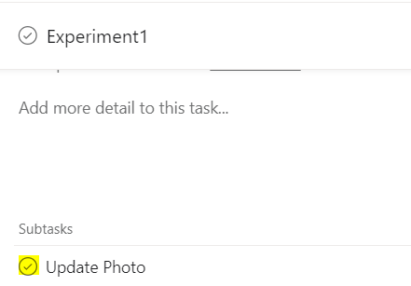

That’s it! Our website staff will automatically be notified that there’s a new picture waiting for them to put up on the website. *Note: if this box is already checked, see Option 3.*

*Option 2*:

In the FCAS Content Creators project, you can see all dogs who need an updated photo in the Update Photo column. Scroll through to find the dog you’re looking for (i.e. “Experiment1”), and click the check mark next to Update Photo.

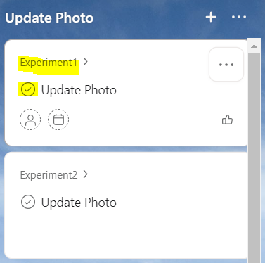

That’s it! Our website staff will automatically be notified that there’s a new picture waiting for them to put up on the website. *Note: if the dog you’re looking for isn’t in the Update Photo section, see Option 3.*

*Option 3:*

If the dog already has a website photo, the Update Photo subtask will already be checked off, and a task will not show up in the FCAS Content Creators project. However, if you believe your new photos should be considered as the dog’s new website photo (better lighting, shows more personality, dog looking at the camera, etc.), follow the steps below. Alternatively, if your photos aren’t better quality than the existing website photo but still show something new about the dog (being playful/silly, interacting w/ people, in a home or non-shelter environment), they could be great additions to a dog’s flyer.

If you aren’t sure, follow the below process anyway. The content creators will review your updates and complete their tasks again as they see fit, and it’s easier to follow the process than for the creators to have to track down new photos without being notified.

Search the dog’s name in Asana using the Search bar at the top of the screen. Click on the dog that you’re searching to open their Asana card. Under subtasks, you will see what’s already been completed. Leave “Update Photo” checked. If other subtasks are not yet completed (i.e. checks are now green), no further action is required. Otherwise, if you are hoping to replace the website photo, uncheck the “Update Website Photo” subtask as well as the “Create/Update Kennel Flyer” and “Print Kennel Flyer” subtasks. For flyer additions only, uncheck only the “Create/Update Flyer” and “Print Flyer” subtasks.

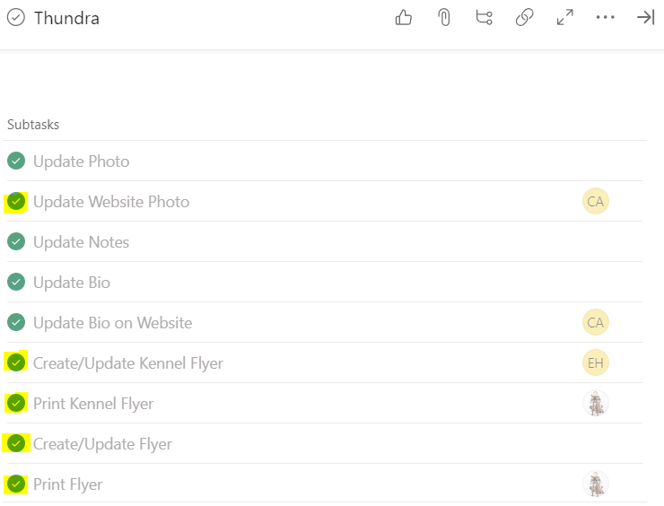

**Update Notes**

Did you spend time with a dog today? We would love to know anything and everything that you learned about them! *What was their personality like? What activities did they enjoy? Did they have a favorite toy? Did they know any tricks? Was their crate clean and they peed a river as soon as you took them out? Did they interact with potential adopters and/or kids? Did they react to other dogs? How were they on leash?* Answers to these questions and anything else you might have to say about them are a great starting point for us advertising them through bios, flyers, and social media posts. Please drop your comments in the comment box at the bottom of a dogs card in Asana:

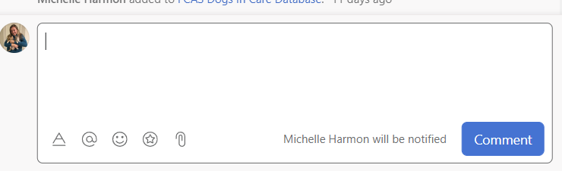

To let everyone know the dog has notes follow the steps below:

*Option 1*:

Search the dog’s name in Asana using the Search bar at the top of the screen. Click on the dog that you’re searching to open their Asana card. Under subtasks, click the check mark next to “Update Notes”.

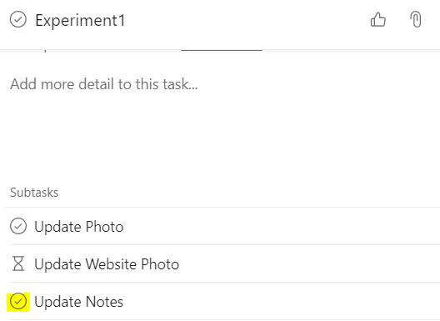

That’s it! Our bio writers and content creators will be alerted that it’s time to get to work. *Note: if this box is already checked, see Option 3.*

*Option 2*:

In the FCAS Content Creators project, you can see all dogs who need updated notes in the Update Notes column. Scroll through to find the dog you’re looking for (i.e. “Experiment1”), and click the check mark next to Update Photo.

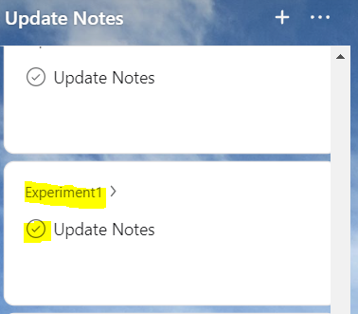

That’s it! Our bio writers and content creators will be alerted that it’s time to get to work. *Note: if the dog you’re looking for isn’t in the Update Notes section, see Option 3.*

*Option 3:*

If the dog already has notes, the Update Notes subtask will already be checked off, and a task will not show up in the FCAS Content Creators project. However, if you believe your notes add something new that has already been shared, they could make great additions to the dog’s bio and flyers.

If you aren’t sure, follow the below process anyway. The content creators will review your updates and complete their tasks again as they see fit, and it’s easier to follow the process than for the creators to have to track down new notes without being notified.

Search the dog’s name in Asana using the Search bar at the top of the screen. Click on the dog that you’re searching to open their Asana card. Under subtasks, you will see what’s already been completed. Leave “Update Notes” checked. If other subtasks are not yet completed (i.e. checks are now green), no further action is required.

Otherwise, the bio will be in the Description and the kennel and full page flyers should show as attachments below the Subtasks section. Depending on your notes, you may only wish to update the bio if your notes are more specific. Uncheck the “Update Bio” and “Update Bio on Website” subtasks. For more general notes, uncheck the the “Create/Update Kennel Flyer” and “Print Kennel Flyer” subtasks and the “Create/Update Flyer” and “Print Flyer” subtasks. Some notes will fall somewhere in the middle, so use your discretion based on what’s already on each flyer.

